**Frontend Development with React.js**

**Project Documentation format**

1. **Introduction**
   * **Project Title**: [Cookbook]
   * **Team Members**:
   * Siva.N (LEADER)
   * Mageshwaran.B
   * Mathesh.R
   * Prabanjan.S.K
2. **Project Overview**
   * **Purpose**: collect and organise recipes in one place
   * **Features:** Provide easyinstructions for cooking
3. **Running the Application**
   * Provide commands to start the frontend server locally.
     + **Frontend**: npm start in the client directory.
     + **Visual studio**
4. **Component Documentation**
   * **Key Components**: Document major components, their purpose, and any props they receive.
   * **Reusable Components**: Detail any reusable components and their configurations.
5. **Testing**

* **Testing Strategy**: Describe the testing approach for components, including unit, integration, and end-to-end testing (e.g., using Jest, React Testing Library).
* **Code Coverage**: Explain any tools or techniques used for ensuring adequate test coverage.

1. **Screenshots or Demo**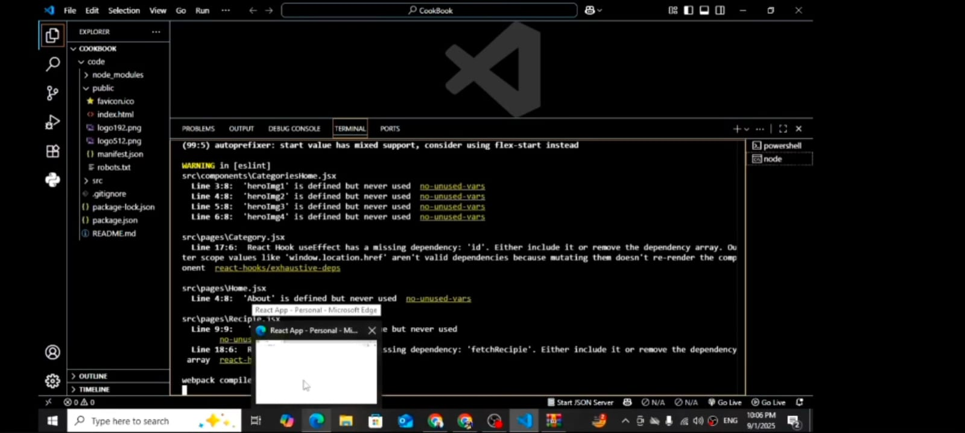

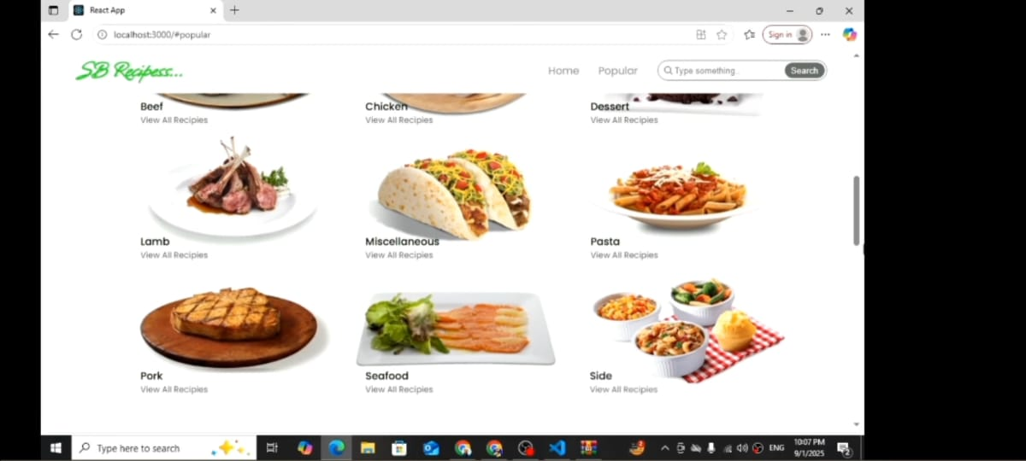

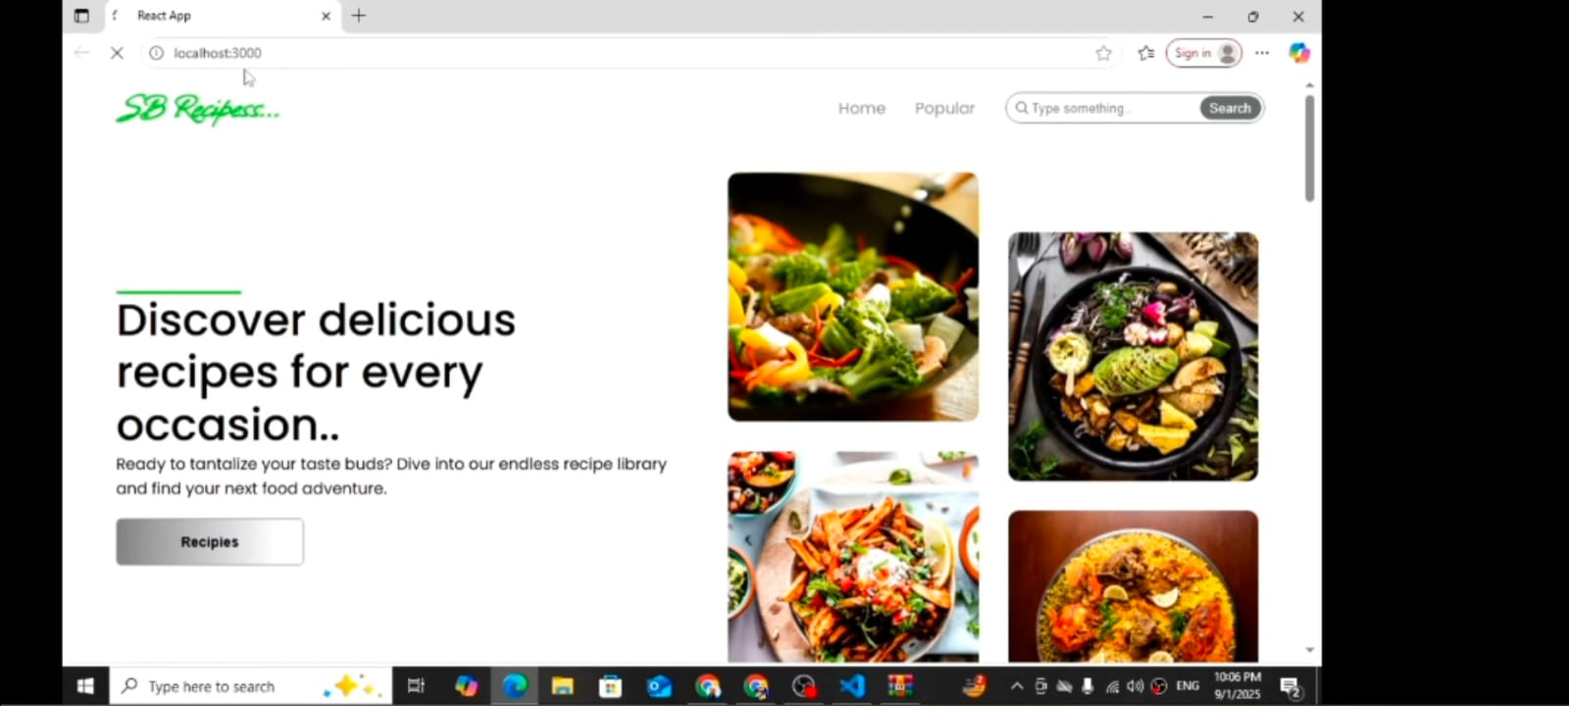

* Provide screenshots or a link to a demo showcasing the application’s features and design.

1. **Known Issues**

* Document any known bugs or issues that users or developers should be aware of.

1. **Future Enhancements**

* Outline potential future features or improvements, such as new components, animations, or enhanced styling.

**DOCUMENTATION**

<https://drive.google.com/file/d/1KwIuABnbMkruCwszDxvYfjnmIGKFuzcm/view?usp=drivesdk>